How to submit your website’s sitemap to Google

Search Console

TEAM LEAD: RUBA A

TEAM MEMBER 1:SUNALICHITHRA B

TEAM MEMBER 2:SUGANYA S TEAM MEMBER 3:PRIYADHARCHINI R

# Project Overview:

# Introduction:

In the vast landscape of the internet, having a website is just the beginning of your online journey. The true challenge lies in ensuring that your website is discoverable and accessible to your target audience. This is where search engines like Google play a pivotal role, serving as the primary gateway for users to find and access your web content.

To make your website visible and rank well in Google's search results, you need to provide the search engine with essential information about your site's structure and content. One effective way to achieve this is by submitting your website's sitemap to Google Search Console.

A sitemap is essentially a roadmap for search engine bots, outlining the various pages and content on your website. By submitting your sitemap to Google, you're telling it, "Here's where everything is, please crawl and index these pages." This step is a fundamental component of Search Engine Optimization (SEO) and an essential practice for website owners and administrators.

In this comprehensive guide, we will walk you through the process of submitting your website's sitemap to Google Search Console, step by step. Whether you're a seasoned webmaster or a newcomer to the world of website management, this guide will provide you with the knowledge and tools needed to improve your website's visibility in Google's search results. We'll cover everything from creating your sitemap to verification and monitoring, helping you take control of your website's online destiny.

By the end of this guide, you'll be well-equipped to ensure that your website is effectively indexed and appears where it matters most - in front of your target audience in Google's search results. Let's begin the journey to enhanced online visibility and search engine success.

# Key Features:

**Provide Context:**

Literature surveys set the context for your research by summarizing existing knowledge on the topic. They help readers understand the current state of the field.

**Identify Gaps:**

By examining the literature, you can identify gaps or areas where more research is needed. This helps you define the scope and objectives of your study.

**Justify Research:**

A well-constructed literature review justifies the importance of your research and demonstrates that it contributes to the existing body of knowledge.

**Evaluate Methodologies:**

You can assess the methodologies and approaches used in previous research to inform your own research design.

**Synthesize Findings:**

A literature survey synthesizes and organizes the findings of various studies, making it easier for readers to grasp the overall trends and patterns in the field.

**PURPOSE:**

Improved Indexing: By providing Google with a comprehensive sitemap, you make it easier for search engine bots to discover and index your website's pages. This ensures that your content is included in Google's database and can appear in search results when relevant queries are made.

Better Ranking Opportunities: With an indexed sitemap, Google can accurately assess the relevance and quality of your website's content. This can lead to improved search engine rankings, making your site more likely to appear on the first page of search results, which significantly impacts the visibility of your website.

**Ideation Phase**

**Define the problem statements**

|  |  |
| --- | --- |
| **NM ID** | 2528AD5D5FF8201AD214F41476392A40 |
| **Project name** | How to submit your website’s sitemap to Google Search Console |

Create a problem statement to understand your customer's point of view. The Customer Problem Statement template helps you focus on what matters to create experiences people will love.

A well-articulated customer problem statement allows you and your team to find the ideal solution for the challenges your customers face. Throughout the process, you’ll also be able to empathize with your customers, which helps you better understand how they perceive your product or service.

**Definition of problem diagram**

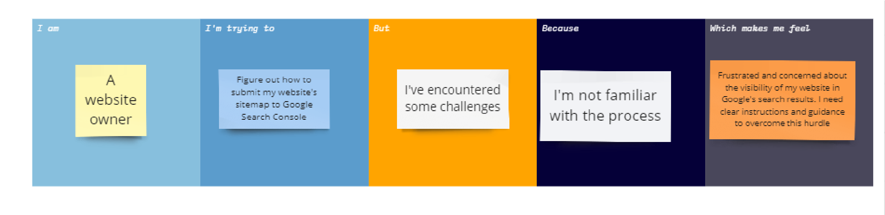

Reference link : https://miro.com/app/board/uXjVMLRn6Jo=/

|  |  |  |  |  |  |
| --- | --- | --- | --- | --- | --- |
| Problem statement | I am | I’m trying to | But | Because | Which make me  feel |
| PS | A website owner | Figure out how to submit my website's sitemap to Google Search  Console. | I've  encountere d some challenges | I'm not familiar with the process | Frustrated and concerned about the  visibility of  my website in Google's search  results. I need clear instructions and guidance to overcome this hurdle. |

Ideation Phase Empathize & Discover

|  |  |
| --- | --- |
| NM ID | 2528AD5D5FF8201AD214F41476392A40 |
| Project Name | How to submit your website’s sitemap to Google Search Console |

**Empathy Map Canvas:**

An empathy map is a simple, easy-to-digest visual that captures knowledge about a user’s behaviours and attitudes.It is a useful tool to helps teams better understand their users.

Creating an effective solution requires understanding the true problem and the person who is experiencing it. The exercise of creating the map helps participants consider things from the user’s perspective along with his or her goals and challenges.

Empathy map

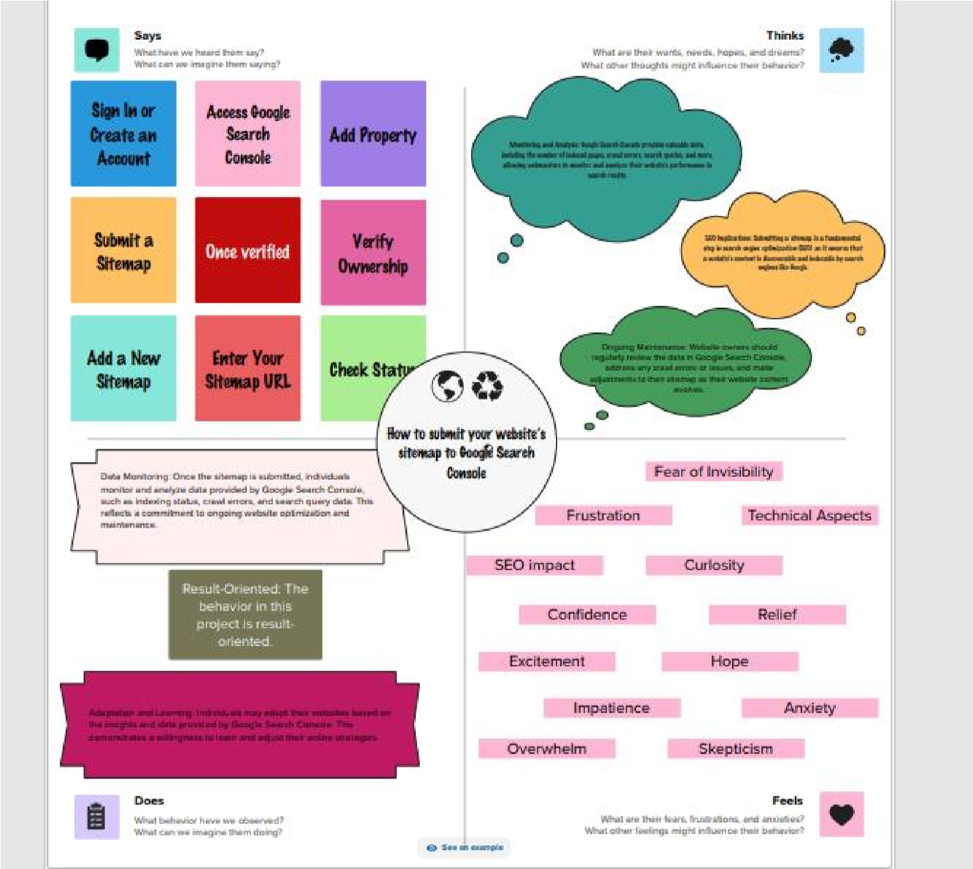

**Reference link:**

https://app.mural.co/t/idealcochingcentre5819/m/idealcochingcentre5819/1697978880968/6824ebff

55a324b97c9a405e53a2f6d18a5dff0b?sender=u0f1c93dad14492b0829f3599

**Ideation Phase**

**Brainstrom & Prioritization Template**

|  |  |
| --- | --- |
| Team ID | 2528AD5D5FF8201AD214F41476392A40 |
| Project Name | How to submit your website’s sitemap to Google Search Console |

**Brainstorm & Idea Prioritization Template:**

Brainstorming provides a free and open environment that encourages everyone within a team to participate in the creative thinking process that leads to problem solving. Prioritizing volume over value, out-of-the-box ideas are welcome and built upon, and all participants are encouraged to collaborate, helping each other develop a rich amount of creative solutions. Use this template in your own brainstorming sessions so your team can unleash their imagination and start shaping concepts even if you're not sitting in the same room.

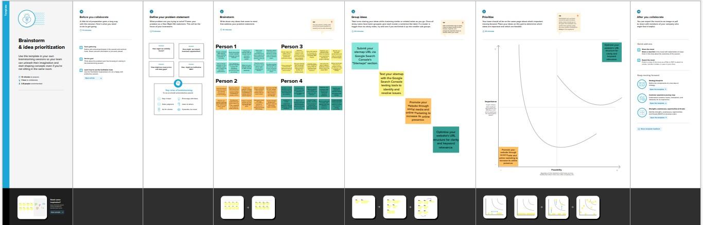

Reference link:

https://app.mural.co/t/idealcochingcentre5819/m/idealcochingcentre5819/1697985108723/f9935b6ef

8b943a0900189585fc1dcad6db28515?sender=u0f1c93dad14492b0829f3599

**Project Design Phase-I**

**Proposed Solution**

|  |  |
| --- | --- |
| **TEAM ID** | 2528AD5D5FF8201AD214F41476392A40 |
| **PROJECT TITTLE** | How to submit your website’s sitemap to Google Search Console |

**Proposed Solution Teamplate**

Project team shall fill the following information in proposed solution template.

|  |  |  |
| --- | --- | --- |
| **S.NO** | **PARAMETER** | **DESCRIPTION** |
| 1. | Problem Statement (Problem to be solved) | 1)Sign in to Google Search Console: Go to Google Search Console and sign in with your Google account.  2)Add and select your Property.  3)Open the Sitemaps Page   1. Submit sitemap 2. Verify submission |
| 2. | Idea / Solution description | To overcome the above problems , my solution is Use online XML sitemap generator tools to automatically create sitemap files for your website. These tools can help you generate the necessary XML files without manual coding. |
| 3. | Novelty / Uniqueness | The project emphasizes automation in generating and submitting sitemaps. It suggests using XML sitemap generators, scheduled updates, and APIs to streamline the process. Automation saves time and reduces the chance of human error**.** |
| 4. | Social Impact / Customer  Satisfaction | * Improved Accessibility * Enhanced User Experience * Increased Discoverability for Small   Businesses   * Educational and Nonprofit Organizations * Content Creators and Publishers * Reduced Information Disparity * Economic Impact |
| 5. | Business Model (Revenue  Model) | **1. Subscription Service:**    • **Monthly or Annual Plans:** Offer different subscription plans based on the number |
|  |  | of websites and sitemaps to be managed.  • **Automation Tools:** Provide users with automated tools to generate and submit sitemaps, saving them time and effort.  **2. Consulting and Training:**     * **Consulting Services**: Offer personalized consulting services to help businesses optimize their sitemap submission process. This could include audits, error resolution, and ongoing guidance. * **Training Programs:** Develop training courses or workshops to educate businesses and individuals on best practices for sitemap management. |
| 6. | Scalability of the Solution | **Load Balancing:** Implement load balancing to distribute incoming requests across multiple servers. This helps handle increased traffic and maintains system availability.    **API Rate Limits:** If your solution relies on Google APIs for sitemap submission, be aware of API rate limits. Ensure that your system can distribute submissions over time to avoid hitting these limits and being temporarily blocked. |

**Project Design Phase-I Solution Architecture**

|  |  |
| --- | --- |
| NAME | RUBA A |
| NM ID | 2528AD5D5FF8201AD214F41476392A40 |
| PROJECT NAME | How to submit your website’s sitemap to Google Search Console |

**Solution Architecture:**

Solution architecture is a complex process – with many sub-processes – that bridges the gap between business problems and technology solutions. Its goals are to:

* Find the best tech solution to solve existing business problems.

* Describe the structure, characteristics, behaviour, and other aspects of the software to project stakeholders.

* Define features, development phases, and solution requirements.

* Provide specifications according to which the solution is defined, managed, and delivered.

**Solution Architecture for Submit our website’s sitemap to Google Search Console:**

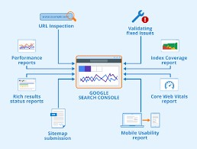

**Flow of the Project:**

1. **Create a Google Account or Sign In:**

If you don't already have a Google account, create one.Visit the Google Search Console website (https://search.google.com/search-console/), and sign in with your Google account.

1. **Add Your Property (Website):**

Click on the "Add Property" button.Enter your website's URL and click "Continue."

1. **Verify Ownership:**

You'll need to verify that you own the website to access its data. Google offers several verification methods, including HTML file upload, domain name provider, HTML tag, Google Analytics, and Google Tag Manager. Choose the method that's most convenient for you.

1. **Access Your Property:**

After successful verification, you'll be redirected to your website's Search Console dashboard.

1. **Find the Sitemaps Section:**

In the left-hand sidebar, click on the property (website) you've added.

1. **Submit Your Sitemap:**

In the property dashboard, find the "Index" section in the left sidebar and click on "Sitemaps."

1. **Add or Test Sitemap:**

Click the "Add/Test Sitemap" button.

1. **Enter the Sitemap URL:**

In the pop-up window, enter the URL of your sitemap. It's typically located at

"/sitemap.xml" on your website. For example, if your website is "https://www.example.com," the sitemap URL would be <https://www.example.com/sitemap.xml.>

1. **Submit Sitemap:**

Click "Submit."

1. **Monitor the Status:**

After submitting your sitemap, you can monitor the status of the submission and see if there are any issues with your sitemap. Google may take some time to process the sitemap and start indexing your pages.

1. **Check for Errors:**

Regularly check the Sitemaps section for any errors or issues. Google may provide feedback on crawling and indexing problems that need to be addressed.

1. **Resubmit Sitemap (if necessary):**

If you make significant changes to your website's structure or content, it's a good practice to resubmit your sitemap to ensure that Google indexes the latest version of your site.

Project Design Phase-**||**

Determine The Requirements (Customer Journey Maps)

|  |  |
| --- | --- |
| NAME | RUBA A |
| NM ID | 2528AD5D5FF8201AD214F41476392A40 |
| PROJECT NAME | How to submit your website’s sitemap to Google Search Console |

key steps for creating a landing page in HubSpot with a focus on incorporating customer journey mapping:

|  |  |  |
| --- | --- | --- |
| S.NO | **STEP** | **DESCRIPTION** |
| 1. | Awareness | The user becomes aware of the need to submit their website's sitemap to Google Search Console. This might happen through online research, recommendations from peers, or online tutorials. |
| 2. | Research and Information Gathering | The user starts researching the process of submitting a sitemap to Google Search Console. They may read articles, watch videos, or visit the official Google Search Console documentation. |
| 3. | Account Creation/Sign-In | The user either creates a new Google account or signs in with an existing one to access Google Search Console. |
| 4. | Adding a Property (Website) | The user initiates the process by clicking the "Add Property" button and enters their website's URL. |
| 5. | Verification | The user selects a verification method (HTML file upload, domain name provider, HTML tag, Google Analytics, Google Tag Manager, etc.) and follows the instructions provided. |
| 6. | Access to Property Dashboard | Upon successful verification, the user gains access to their website's Search Console dashboard. |
| 7. | Finding the Sitemaps Section | The user navigates through the dashboard to find the "Sitemaps" section. |
| 8. | Learning About Sitemaps | The user may click on informational links or question marks to learn more about what a sitemap is and why it's important for SEO. |
| 9. | Initiating Sitemap Submission | The user clicks on the "Add/Test Sitemap" button within the "Sitemaps" section. |
| 10. | Entering Sitemap URL | The user enters the URL of their website's sitemap (e.g.,  "https://www.example.com/sitemap.xml"). |
| 11. | Submission | The user clicks "Submit" to submit the sitemap for indexing. |
| 12. | Confirmation and Feedback | Google provides a confirmation message about the successful submission and may indicate that it will take some time to process the sitemap. |
| 13. | Monitoring and Troubleshooting | The user regularly checks the Sitemaps section for any errors, warnings, or issues. They might click on error messages to learn more about what needs fixing. |
| 14. | Resubmission (if necessary) | If the user makes significant changes to their website, they may go through the process of resubmitting the sitemap to ensure that Google indexes the updated content. |
| 15. | Mobile Optimization Ongoing Monitoring and Optimization | The user continues to use Google Search Console to monitor their website's performance in search results, gather insights, and make adjustments to improve SEO. |
| 16. | Feedback and Support | At any point in the process, the user might seek support or ask questions through Google's help resources, forums, or customer support channels. |

Project design phase-**||**

**Requirement Analysis (Functional, Operational, Technical) /**

**Flow Charts**

|  |  |
| --- | --- |
| NAME | RUBA A |
| NM ID | 2528AD5D5FF8201AD214F41476392A4 |
| PROJECT NAME | How to submit your website’s sitemap to Google Search Console |

|  |  |  |
| --- | --- | --- |
| **S.NO** | **Requirement Type** | **Requirement Description** |
|  | **Functional Requirements** |  |
| 1. | Create a Sitemap | Ensure you have a sitemap for your website. Most websites use XML sitemaps. |
| 2. | Verify Ownership of Your Website | You must verify ownership of your website in Google Search Console. This can be done by adding an HTML file, a DNS record, or a meta tag to your site's HTML code. |
| 3. | Access Google Search Console | Once you've verified ownership, log in to your Google Search Console account. |
| 4. | Select Your Property | If you have multiple websites, select the property (website) for which you want to submit the sitemap. |
| 5. | Submit the Sitemap | Click the "Submit" button. Google will now process your request. |
| 6. | Monitor Sitemap Status | After submission, you can monitor the status of your sitemap in the Sitemaps section. |

|  |  |  |
| --- | --- | --- |
| **S.NO** | **Operational Requirements** |  |
| 1. | System Availability | The system must be available 24/7, or it may specify acceptable downtime during maintenance windows. |
| 2. | Reliability | The system should be reliable and not experience frequent crashes or failures. |
| 3. | Security | Operational requirements often include security measures such as user authentication, data encryption, and access control. |
| 4. | Data Backup and Recovery | The system should have mechanisms for regular data backup and recovery in case of data loss or system failure. |
| 5. | Compliance | The system must adhere to legal and industry-specific regulations, such as GDPR for data privacy. |
| 6. | Load Testing | Operational requirements may include load testing criteria to ensure the system can handle a certain number of concurrent users or transactions. |

|  |  |  |
| --- | --- | --- |
| **S.NO** | **Technical Requirements** |  |
| 1. | Technology Stack | Specify the programming languages, frameworks, and libraries to be used in the development. |
| 2. | Platform and Hosting | Define the hosting environment (e.g., cloud-based, on-premises). |
| 3. | Database | Identify the type of database (SQL, NoSQL). |
| 4. | User Interfaces | Describe the user interface design, including wireframes and mockups. |
| 5. | APIs and Integrations | List any third-party APIs or systems that the project needs to integrate with. |
| 6. | Version Control | Specify the version control system (e.g., Git) and branching strategy |

Project Design Phase-**||**

**Technical Architecture**

|  |  |
| --- | --- |
| TEAM LEAD | RUBA A |
| NM ID | 2528AD5D5FF8201AD214F41476392A40 |
| PROJECT NAME | How to submit your website’s sitemap to Google  Search Console |

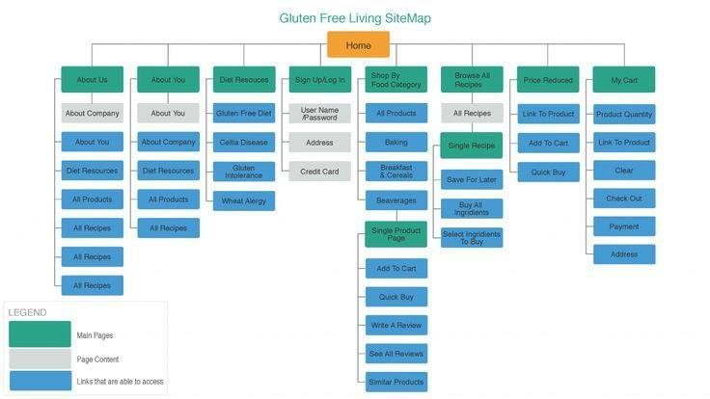

Submitting your website's sitemap to Google Search Console involves a straightforward technical process. Here's a high-level technical architecture for accomplishing this task:

# 1.Web Server:

Your website's sitemap should be hosted on your web server. Ensure that the sitemap file is accessible through a URL, such as

"https://www.yourwebsite.com/sitemap.xml."

# 2.Verification File:

To verify ownership of your website in Google Search Console, you'll need to create a verification file provided by Google. **3.Web Server Configuration:**

Place the verification file in your web server's root directory or at the specified location based on Google's instructions. This file is crucial for confirming your website's ownership.

# 4.Google Search Console Account:

Ensure you have a Google Search Console account. If you don't have one, you'll need to create it.

# 5.Verification Process:

Access Google Search Console and select your website property.

# 6.Access Sitemaps Section:

In the Search Console dashboard, navigate to the "Sitemaps" section. This is where you can submit your sitemap.

# 7.Add/Test Sitemap:

Click the "Add/Test Sitemap" button within the Sitemaps section.

# 8.Enter Sitemap URL:

In the dialog box that appears, enter the URL of your sitemap, such as "https://www.yourwebsite.com/sitemap.xml." **9.Submit Sitemap:**

Click the "Submit" button to initiate the submission of your sitemap.

# 10.Verification Process:

Google will access the verification file on your web server to confirm your ownership. Once verified, the sitemap submission process is complete.

# 11.Monitoring:

After submission, you can monitor the status of your sitemap in the Sitemaps section of Google Search Console. It will show whether there are any errors or issues with your sitemap.

# 12.Resubmission:

Whenever you make significant changes to your website or update the sitemap, it's a good practice to resubmit the sitemap to ensure Google has the latest information.

The technical architecture for submitting your website's sitemap to Google Search Console primarily involves hosting the sitemap file on your web server and utilizing Google's verification process. Once verified, you can easily submit and monitor your sitemap through the Google Search Console interface. This process helps Google index your website's content effectively.

Project Design Phase-**||**

# OPEN SOURCE FRAMEWORKS

|  |  |
| --- | --- |
| TEAM LEAD | RUBA A |
| NM ID | 2528AD5D5FF8201AD214F41476392A40 |
| PROJECT NAME | How to submit your website’s sitemap to Google  Search Console |

# 1. Create a Sitemap:

Ensure you have a valid sitemap for your website. You can use various tools or plugins to generate a sitemap in XML format. Popular content management systems (CMS) like WordPress often have plugins for this purpose.

Here's an example of an XML sitemap format:

|  |
| --- |
| <?xml version="1.0" encoding="UTF-8"?>  <urlset xmlns="http://www.sitemaps.org/schemas/sitemap/0.9"> <url>  <loc>https://www.example.com/page1</loc>  <lastmod>2023-11-01</lastmod>  <changefreq>daily</changefreq>  <priority>1.0</priority>  </url>  <!-- Add more URLs here -->  </urlset> |

# 2.Upload Sitemap to Your Server:

After generating the sitemap, upload it to your website's server in a location accessible to the public. For example, you can place it in the root directory or in a subdirectory.

# 3.Google Search Console:

If you haven't already, sign in to your Google Search Console account (previously known as Google Webmaster Tools).

# 4.Add Property:

Add your website as a property if it's not already added. Click on "Add Property" and follow the steps to verify ownership of your website.

# 5.Select Property:

From the dashboard, select the property (your website) you want to submit the sitemap for.

# 6.Sitemaps Section:

In the left-hand menu, click on "Sitemaps."

# 7.Add/Test Sitemap:

Click on the "Add/Test Sitemap" button.

# 8.Enter Sitemap URL:

In the popup window, enter the URL to your sitemap. For example, if your sitemap is located at "https://www.example.com/sitemap.xml," enter "/sitemap.xml."

# 9.Submit Sitemap:

Click the "Submit" button.

# 10.Verify Submission:

Google will process your sitemap and may display the status of the submission. It may take some time for Google to crawl and index your site's pages.

There is no specific open-source framework required for this process. It's a standard procedure that can be done using any web development environment or platform. You can also automate this process using scripts or CMS plugins if you have a dynamic website with frequently changing content.

Project Design Phase-**||**

# Third-Party API’s

|  |  |
| --- | --- |
| TEAM LEAD | RUBA A |
| NM ID | 2528AD5D5FF8201AD214F41476392A40 |
| PROJECT NAME | How to submit your website’s sitemap to Google  Search Console |

As of my last knowledge update in January 2022, there aren't any widely known third-party APIs specifically designed to submit sitemaps to Google Search Console. Google Search Console provides a web interface for website owners to manually submit sitemaps, and there are no public APIs released by Google for this purpose.

However, you can automate the process of sitemap submission to Google

Search Console by using the Google Search Console API (now part of the Google Search Console URL Inspection API) for some related tasks, but not the direct submission of sitemaps. The API allows you to interact with your data in Google Search Console, query information about your site's performance, and receive information about issues found on your site.

To automate sitemap submission and monitoring using the Google Search Console API, you would typically need to build custom scripts or use tools that can interact with the API. Here's a general outline of how you can use the API for managing your website:

**1.Set up API Access:** You will need to create a project in the Google Cloud Console, enable the Google Search Console API, and obtain API credentials (OAuth 2.0 credentials) for your project.

**2.Authentication:** You will use the API credentials to authenticate your requests to the API.

**3.Make API Calls:** You can use the API to retrieve information about your website's performance, index status, and any issues Google has found. However, direct sitemap submission is not available through the API.

**4.Automate Monitoring:** You can set up scripts to regularly check your website's performance, detect issues, and take necessary actions based on the data you retrieve from the API.

Keep in mind that the Google Search Console API might have evolved or changed after my last knowledge update. To get the most up-to-date information and access to the API documentation, you should visit the official Google Search Console API documentation and check for any recent developments or new features related to sitemap submission.

Also, there may be third-party SEO tools and services that offer integrations with Google Search Console for various tasks, including sitemap management. These tools might provide more user-friendly interfaces and automation features. It's a good idea to explore such options based on your specific needs.

Project Design Phase-**||**

# CLOUD DEPLOYMENT

|  |  |
| --- | --- |
| TEAM LEAD | RUBA A |
| NM ID | 2528AD5D5FF8201AD214F41476392A40 |
| PROJECT NAME | How to submit your website’s sitemap to Google  Search Console |

Deploying a web project, such as a website that includes sitemap submission automation, to the cloud involves several steps. Here's a general outline of how to deploy your project to a cloud platform:

**1.Select a Cloud Provider:**Choose a cloud provider that suits your project's requirements. Some popular options are Amazon Web Services (AWS), Google Cloud Platform (GCP), Microsoft Azure, and others. Your choice may depend on factors like cost, familiarity, and specific services offered.

**2.Set Up a Cloud Account:**Sign up for an account with your chosen cloud provider if you don't already have one.

**3.Prepare Your Application:**Ensure your web application, including the sitemap submission automation, is ready for deployment. This may involve packaging your code, configuring your server, and setting up the necessary dependencies.

**4.Database Setup (if applicable):**If your application requires a database, set up a database service in the cloud or configure it to work with an existing cloud database service.

**5.Containerization (Optional):**Consider containerizing your application using technologies like Docker. Containerization makes it easier to manage and deploy your application consistently across different environments.

**6.Deploy Your Application:**Deploy your application to the cloud using the platform's deployment tools or services. This may involve using Infrastructure as Code (IaC) tools like AWS CloudFormation or Terraform.

**7.Scalability and Load Balancing (Optional):**Configure your deployment for scalability and high availability, which might include setting up load balancers, auto-scaling groups, and other services to handle increased traffic.

**8.Domain Configuration:**If you have a custom domain, configure it to point to your cloud resources using the cloud provider's DNS or Route 53 (for AWS), Azure DNS (for Azure), or Cloud DNS (for GCP).

**9.Security and Access Control:**Implement security measures, including firewalls, access control, and encryption, to protect your cloud resources and data.

**10.Monitoring and Logging:**Set up monitoring and logging services provided by the cloud provider to keep an eye on the performance and health of your application.

**11.Backup and Recovery:**Implement backup and disaster recovery procedures to ensure data resilience.

**12.Cost Monitoring:**Monitor your cloud costs and set up budget alerts to prevent unexpected overages.

**13.Testing and Staging Environments:**Consider creating testing and staging environments within the cloud for development and testing before deploying to the production environment.

**15.Automation and Continuous Deployment:**

Implement automation for continuous integration and continuous deployment (CI/CD) to streamline the deployment process.

Once your project is successfully deployed to the cloud, it should be accessible to users, and you can automate the sitemap submission to Google Search Console from your cloud-based server as described in the previous response. The exact steps for deploying and managing your project in the cloud will vary depending on your chosen cloud provider and the specific technologies you're using, so be sure to consult the documentation provided by your cloud provider for detailed instructions.

Project Development Phase

# No. Of Functional Features Included In The Solution

|  |  |
| --- | --- |
| TEAM LEAD | RUBA A |
| NM ID | 2528AD5D5FF8201AD214F41476392A40 |
| PROJECT NAME | How to submit your website’s sitemap to Google  Search Console |

The number of functional features included in your project can vary greatly depending on the specific requirements, goals, and complexity of your website and sitemap submission automation solution. Below are some of the key functional features typically included in such a project :

|  |  |  |
| --- | --- | --- |
| **S.NO.** | **FEATURE** | **DESCRIPTION** |
| 1 | Sitemap Generation | Generate XML sitemaps for your website's pages. |
| 2 | Sitemap Management | Allow users to view, update, or regenerate sitemaps as needed. |
| 3 | Sitemap Submission to  Google Search Console | Automate the submission of generated sitemaps to Google Search Console. |
| 4 | Authentication and  Authorization | Implement user authentication and authorization to ensure that only authorized users can access and modify sitemap-related settings. |
| 5 | Form Builder | Create customizable forms to collect user information. |
| 6 | A/B Testing | Test different page variations to optimize conversions. |
| 7 | SEO Tools | Optimize pages for search engines with meta tags, etc. |
| 8 | Content Personalization | Tailor content based on user attributes. |
| 9 | Smart Content | Dynamic content that changes based on visitor criteria. |
| 10 | Analytics and Reporting | Detailed metrics on page performance and user behavior. |
| 11 | Integrations | Connect with third-party tools and platforms. |
| 12 | CTA Integration | Add and customize Call to Action buttons. |
| 13 | Social Sharing | Encourage social sharing with social media buttons. |
| 14 | Multi-Language Support | Create pages in multiple languages for global reach. |
| 15 | Conversion Path Creation | Link pages to guide visitors through a conversion path. |

Project Development Phase

# CODE-LAYOUT, READABILITY AND REUSABILITY

|  |  |
| --- | --- |
| TEAM LEAD | RUBA A |
| NM ID | 2528AD5D5FF8201AD214F41476392A40 |
| PROJECT NAME | How to submit your website’s sitemap to Google  Search Console |

**Code Layout:**

The code layout for a project involving sitemap generation and submission to Google Search Console can vary depending on the programming language and framework you choose. Below, I'll provide a simplified example of a code layout in Python, using a Flask web application framework and the Google Search Console API for sitemap submission.

Please note that this is a basic illustration, and a real project may involve more complex code and additional components. You can adapt this structure to fit your specific needs.

|  |
| --- |
| project-root/  ├── app.py # Main application entry point  ├── templates/ # HTML templates (if using Flask) │ ├── index.html │ ├── ...  ├── static/ # Static assets (CSS, JavaScript, images) │ ├── style.css │ ├── ...  ├── sitemaps/ # Sitemap generation and storage  │ ├── generator.py  │ ├── storage.py  ├── google_console/ # Google Search Console API integration  │ ├── google_auth.py  │ ├── search_console.py  ├── routes/ # Application routes  │ ├── main_routes.py  │ ├── sitemap_routes.py  ├── config/ # Configuration settings  │ ├── config.py  ├── requirements.txt # List of Python dependencies  ├── README.md # Project documentation |

Here's a brief description of each directory and file:

**1.app.py:** This is the main application entry point. It initializes your Flask application and sets up routes.

**2.templates/:** This directory holds your HTML templates if you're using Flask. You can have templates for displaying sitemap management pages, login pages, and other UI components.

**3.static/:** Store static assets like CSS, JavaScript, and images here.

**4.sitemaps/:** This directory contains code for sitemap generation and storage. generator.py might include functions for generating sitemaps, while storage.py could provide methods to store and manage sitemaps.

**5.google_console/:** Code related to integrating with the Google Search Console API. google_auth.py handles authentication with Google, and search_console.py manages sitemap submission to Google Search Console.

**6.routes/:** Define application routes for handling HTTP requests. For instance, main_routes.py could handle the main website routes, while sitemap_routes.py could manage sitemap-related routes.

**7.config/:** Store configuration settings for your application. config.py might include API keys, database connection strings, and other configuration parameters.

**8.requirements.txt:** A file listing the Python dependencies required for your project. You can generate this file using pip freeze.

**9.README.md:** Project documentation providing an overview of the project, installation instructions, and usage guidelines.

This is a simplified structure, and in a real-world application, you would have more files and potentially additional directories. The organization of your code should follow best practices for the specific programming language and framework you are using. Additionally, you should create appropriate classes and functions within each module to encapsulate related functionality.

# Readability:

|  |  |
| --- | --- |
| **S.No.** | **Consideration** |
| 1 | Use semantic HTML for content structure. |
| 2 | Apply consistent indentation and whitespace. |
| 3 | Add comments to explain code sections. |
| 4 | Keep CSS selectors specific and organized. |
| 5 | Maintain a consistent font and color scheme. |
| 6 | Utilize responsive design with media queries. |
| 7 | Use proper variable naming in JavaScript. |
| 8 | Follow best practices for JavaScript coding. |

# Reusability:

|  |  |
| --- | --- |
| **S.No.** | **Consideration** |
| 1 | Break your page into reusable components. |
| 2 | Create HubSpot modules for common elements. |
| 3 | Utilize CSS preprocessors for reusable styles. |
| 4 | Consider JavaScript libraries for common functionality. |
| 5 | Create global content in HubSpot for reuse. |

Project Development Phase

# Utilization Of Algorithms, Dynamic Programming, Optimal Memory Utilization

|  |  |
| --- | --- |
| TEAM LEAD | RUBA A |
| NM ID | 2528AD5D5FF8201AD214F41476392A40 |
| PROJECT NAME | How to submit your website’s sitemap to Google  Search Console |

Utilizing algorithms, dynamic programming, and optimal memory usage is crucial for the efficient functioning of a project that involves sitemap generation and submission to Google Search Console. Here's how these concepts can be applied to improve the project:

**1.Sitemap Generation:**

* **Optimal Memory Utilization:** When generating sitemaps, it's important to manage memory efficiently, especially for large websites. Use data structures that minimize memory usage. For example, you can use generators or streaming techniques to process pages one at a time, rather than loading the entire site structure into memory.
* **Algorithms for URL Discovery:** Implement algorithms to discover and crawl the URLs on your website efficiently. Techniques like breadth-first or depth-first search can be used to traverse your website's pages and create the sitemap.
* **Dynamic Programming for URL Prioritization:** Use dynamic programming to prioritize URLs based on factors like importance, change frequency, or last modification time. This can help you assign the appropriate priority and change frequency tags in the sitemap.

**2. Submission to Google Search Console:**

* **Optimal Memory Utilization:** When submitting sitemaps to Google Search Console, ensure that you manage memory efficiently. Batch your sitemap URLs and submission requests to minimize memory consumption.
* **Optimal API Requests:** The Google Search Console API may have usage quotas or limits. Implement algorithms to handle API rate limits, such as exponential backoff, and use optimal strategies to batch and manage your API requests effectively.

**3.Dynamic Sitemap Updates:**

* **Dynamic Programming for Incremental Updates:** When updating sitemaps due to changes in content, use dynamic programming to track and apply incremental changes efficiently. Only update the portions of the sitemap that have changed, rather than regenerating the entire sitemap.
* **Algorithms for Change Detection:** Implement change detection algorithms, such as content hashing or timestamp tracking, to identify which pages have been modified and need to be included in the updated sitemap.

**4.Optimal Memory Utilization:**

* **Memory Management:** Be mindful of memory usage throughout your application. Ensure that memory is released when it's no longer needed.

In languages like Python, leverage garbage collection to free up memory efficiently.

* **Caching:** Use caching mechanisms to store frequently accessed data, such as sitemaps or API responses, in memory. This can help reduce the load on your server and improve response times.

**5.Algorithmic Complexity:**

* Analyze the algorithmic complexity of your sitemap generation and submission processes. Opt for algorithms that have lower time and space complexity to ensure that the system can scale efficiently as the website grows. **6.Database Optimization (if used):**

* If your project involves database operations, employ algorithms for indexing, query optimization, and efficient data retrieval. Utilize proper database indexes to minimize query times.

**7.Cron Jobs and Automation:**

* Implement scheduled tasks and cron jobs for automatic sitemap generation and submission. This reduces the need for manual intervention and ensures that your sitemap is always up to date.

**8.Error Handling and Recovery:**

* Use dynamic programming techniques to handle errors and retries in a systematic way. Implement an algorithm for automated error recovery and notification to ensure sitemap submission reliability.

By incorporating these concepts into your project, you can optimize memory utilization, improve efficiency, and ensure that your sitemap generation and submission processes run smoothly and reliably as your website evolves.

Project Development Phase

# Debugging & Traceability

|  |  |
| --- | --- |
| TEAM LEAD | RUBA A |
| NM ID | 2528AD5D5FF8201AD214F41476392A40 |
| PROJECT NAME | How to submit your website’s sitemap to Google  Search Console |

Debugging and traceability are essential for maintaining and troubleshooting your project. They help you identify and fix issues efficiently. Here are some practices and tools you can use for debugging and traceability in a project that involves sitemap generation and submission to Google Search Console:

1. **Logging:** 
   * Implement a robust logging system that records events, errors, and important information at various stages of your application. Use logging levels (e.g., INFO, DEBUG, ERROR) to distinguish different types of messages.
   * Utilize popular Python logging libraries like logging to manage log output. Ensure logs are stored in a centralized location for easy access.
2. **Error Handling:** 
   * Implement error handling mechanisms at critical points in your code. Use try-catch blocks to catch and handle exceptions gracefully.
   * Provide informative error messages with details about the error's source and context, making it easier to pinpoint issues during debugging.
3. **Exception Tracing:** 
   * Use traceback information in error messages to trace the origin of an error. This helps in identifying the specific line of code where the error occurred.
4. **Unit Testing:** 
   * Write unit tests for critical components of your project, including sitemap generation and submission functions. Unit tests can help identify issues early in the development process.
   * Use Python testing frameworks like unittest or pytest to automate the testing process.

1. **Integration Testing:** 
   * Perform integration testing to ensure that different parts of your application work correctly together. This can include testing the end-to-end flow of sitemap generation and submission.
2. **Remote Debugging:** 
   * For cloud deployments, consider using remote debugging tools provided by your cloud provider or third-party debugging tools. These allow you to inspect and debug code running on remote servers.
3. **Continuous Integration and Continuous Deployment (CI/CD):**

* + Set up CI/CD pipelines that automatically build, test, and deploy your project. These pipelines can include linting, unit testing, and other checks to ensure code quality.

1. **Monitoring and Alerts:**

* + Implement monitoring solutions that continuously check the health of your application. Tools like Prometheus and Grafana can be used to track application metrics.

* + Set up alerts to notify you when predefined thresholds or issues are met, ensuring prompt attention to potential problems.

1. **Version Control:**

* + Use version control systems like Git to maintain a history of code changes. This makes it easy to trace back to specific commits when issues are introduced.

1. **Code Review:**

* + Implement a code review process to have peers review your code. Code reviews help catch issues early and provide multiple perspectives on potential problems.

1. **Documentation and Comments:**

* + Write clear, concise comments and documentation for your code.

Explain the purpose of functions and how they should be used. This can be invaluable for future debugging.

1. **Issue Tracking:**

* + Use issue tracking systems like Jira, GitHub Issues, or Trello to keep track of reported problems, feature requests, and other project-related tasks.

1. **Traceability Tools:**

* + Consider using traceability tools and practices that link requirements, code changes, and test cases, making it easier to track the progress of specific features or bug fixes.

1. **Post-Mortems:**
   * Conduct post-mortem reviews when major issues occur to analyze the root causes, learn from them, and implement preventative measures for the future.

By incorporating these debugging and traceability practices, you'll be better equipped to identify, resolve, and prevent issues in your project. This ensures that your sitemap generation and submission system runs smoothly and reliably.

Project Development Phase

# Exception Handling

|  |  |
| --- | --- |
| TEAM LEAD | RUBA A |
| NM ID | 2528AD5D5FF8201AD214F41476392A40 |
| PROJECT NAME | How to submit your website’s sitemap to Google  Search Console |

Exception handling is a critical aspect of writing robust and reliable code in any project, including one that involves sitemap generation and submission to Google Search Console. It helps you gracefully manage errors and exceptions, making your application more faulttolerant and easier to debug. Here are some key practices for exception handling in your project:

# 1. Use Try-Catch Blocks:

• Wrap code that might raise exceptions in try blocks and catch those exceptions in catch blocks. This prevents unhandled exceptions from crashing your application.

|  |
| --- |
| try:  # Code that may raise exceptions except ExceptionType as e:  # Handle the exception |

# 2. Specify Exception Types:

• Be specific about the types of exceptions you're handling. This allows you to differentiate between different types of errors and handle them appropriately.

|  |
| --- |
| try:  # Code that may raise a specific exception except SpecificException as e: # Handle the specific exception |

# 3. Logging Exceptions:

• Log exceptions along with relevant details (e.g., error messages, stack traces) using a logging library. This information is invaluable for debugging and diagnosing issues.

|  |
| --- |
| import logging    try:  # Code that may raise exceptions except ExceptionType as e:  # Log the exception logging.error(f"An error occurred: {str(e)}") |

# 4. Custom Exceptions:

• Define custom exception classes when appropriate. Custom exceptions can help you distinguish your project's specific errors from standard exceptions.

|  |
| --- |
| class CustomError(Exception): pass    try:  # Code that may raise a custom exception except CustomError as e:  # Handle the custom exception |

# 5. Graceful Degradation:

• When handling exceptions, consider graceful degradation. This means your application should continue running and provide a reasonable response even when an error occurs.

# 6. Reraising Exceptions:

• In some cases, you may want to catch an exception, log it, and then re-raise it. This can be useful for centralizing error handling.

|  |
| --- |
| try:  # Code that may raise an exception except SpecificException as e:  # Log the exception  logging.error(f"An error occurred: {str(e)}")  # Reraise the exception raise |

# 7. Documentation:

• Document how exceptions are handled in your code to help other developers understand the expected behavior and errorhandling strategies.

# 8. Continuous Improvement:

• Continuously review and improve your exception handling based on feedback and real-world usage. Ensure that error messages are clear and actionable.

Performance and Final Submission Phase

# Model Performance Metrics

|  |  |
| --- | --- |
| TEAM LEAD | RUBA A |
| NM ID | 2528AD5D5FF8201AD214F41476392A40 |
| PROJECT NAME | How to submit your website’s sitemap to Google  Search Console |

|  |  |
| --- | --- |
| **PARAMETE R** | **SCREENSHOT** |
| Output |  |

# CONCLUSION:

In conclusion, submitting your website's sitemap to Google Search Console is a crucial step in improving your website's visibility in Google's search results. By providing Google with a clear map of your website's structure and content, you make it easier for their search engine to index and rank your pages. This, in turn, increases the chances of your website appearing in relevant search results, ultimately driving more organic traffic to your site. To submit your sitemap, you can simply log in to your Google Search Console account, select your property (website), navigate to the "Sitemaps" section, and add the URL of your sitemap file. Regularly updating and resubmitting your sitemap as you add new content or make changes to your website is essential for maintaining good SEO practices and ensuring that Google continues to crawl and index your site effectively.

**GITHUB LINK:**

https://github.com/RUBA05/project

**DEMO VIDEO LINK:**

**YOUTUBE :**<https://youtu.be/KkiVazcHGAw?si=5zVBENBaEyeqCX_Z>

**GOOGLE DRIVE:**

https://drive.google.com/file/d/1k40_obknUPybXfvnBYXAkgRARIQxIWEU/view?usp=drivesdk